Introduction
Antenatal care is a care of the particular form of medical care given to pregnant women and her baby starting from the time of conception up to the delivery of the baby. Almost 90% of maternal deaths occur in developing countries .Maternal mortality in Bangladesh was 320 per 100,000 live births between the year of 1998 & 2000. Bangladeshi women reported low utilization of ANC approximately 52% of women received ANC from medically trained personnel in 2007. Four pillars of WHO Safe Motherhood Initiative include:
- provision of ANC facilities
- clean & safe delivery
- family planning & contraception
- provision of emergency obstetric care.
Antenatal checkup helps to solve problem if any in its early stage and thus prevents many morbidities and loss of maternal life. Eclampsia is the dangerous complications of pregnancy causing maternal and child death. It could be prevented by early detection by simple examination & tests like ankle oedema, hypertension & proteinuria antenatal checkup helps to solve problem if any in its early stage and thus prevents many morbidities and loss of maternal life.
Eclampsia is the dangerous complications of pregnancy causing maternal and child death. It could be prevented by early detection by simple examination & tests like ankle oedema, hypertension & proteinuria. Woman’s health & behavior in pregnancy affect her baby. A poor diet, smoking, intake of alcohol, certain drugs, severe illness can hold back the babies development. Antenatal care is thus absolutely necessary because it makes sure that the mother and her baby is well & fit.

OBJECTIVES OF THE STUDY:

General Objective:

- To know knowledge & practice of rural mothers regarding ante-natal care in two villages (Sutarpar & Kanishail) of Golapgonj upozila.

Specific Objectives:

- To see knowledge of rural mothers regarding ante-natal care.
- To determine practice of health care of the respondents during ante-natal period.
- To know the reproductive status of the respondents.
- To obtain socio-economic characteristic of the respondents.

METHODOLOGY:

- Type of study: Cross sectional type of descriptive study.

- Study place: Phulbari village of Golapgonj upozila, Sylhet.

- Study population: All the mothers having their last child of five years or less of Phulbari village.

- Sample size: 150

- Sampling technique: Non-probability purposive sampling was done.

- Data collection instrument: A semi-structured questionnaire was used to collect data.

- Data collection technique: Data was collected from the respondents by the researchers (students) themselves by face to face interview.

- Data analysis: On completion of data collection, data were tabulated after checking & verification. Data were analysed by simple statistical method using a computer.

RESULTS

In order to have an idea about the knowledge and practice of rural mothers regarding antenatal care a study was conducted and the related information was collected using questionnaire. Now, the study results are being stated hereafter in the following pages:

Table No –1: Distribution of respondents according to age

Age of the respondents(years) | Total | Percentage (%)
18-21 | 18 | 15.51
22-25 | 36 | 31.03
26-29 | 23 | 19.82
30-34 | 30 | 25.08
≥ 35 | 09 | 07.75
Total | 116 | 100

The table shows that 31.03% of the mothers aged 22-25 years, 15.51% of 18-21years, 19.82% of 26-29 years, 25.08% of 30-34 years and none of the mothers found below 18years,
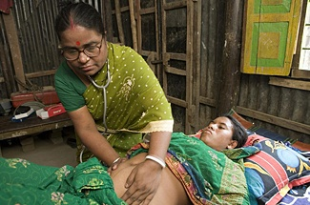

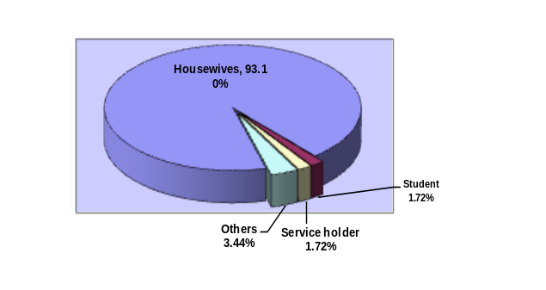Figure-01: Distribution of respondents by occupation
This pie diagram shows that the highest number of respondents were housewives 93% and 1.72% of them were service holders and students each respectively with the remaining 3.44% of other occupations.

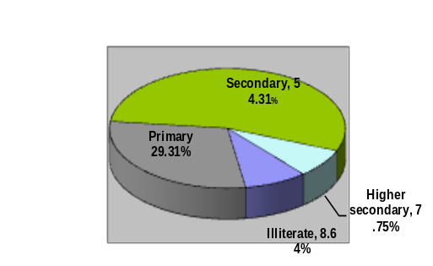Figure-02: Distribution of respondents according to educational status

The above pie diagram reveals that 8.64% mothers were illiterate, 29.31% studied up to primary level, 54.31% studied up to secondary level and only 7.75% up to higher secondary level.
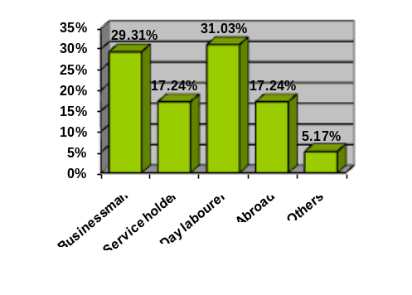Figure-3: Distribution of respondents by husband’s occupation
This simple bar diagram shows that the highest number of husbands were day labourers 31.03% and businessman 23.31% followed by service holders and working abroad both being 17.24% and 5.17% were of other occupations.
Figure No-04: Status of contraceptive used by the respondents
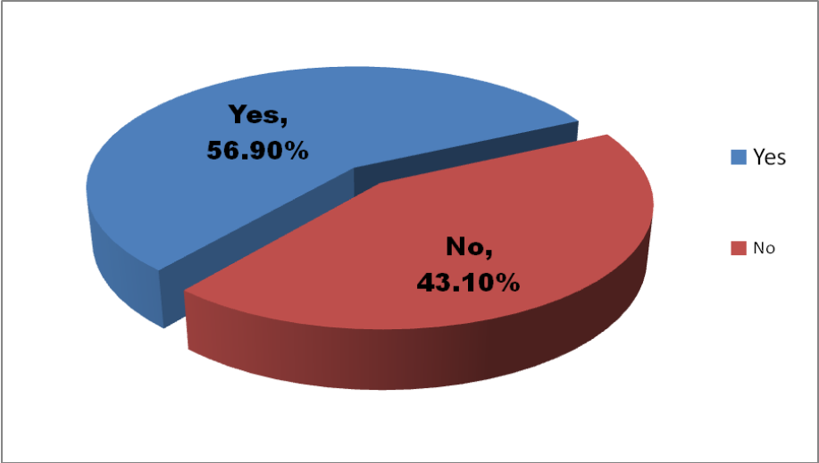

The pie diagram shows that 56.90% of mothers used contraceptives and 43.10% did not.

Table No-2: Distribution of the respondents according to monthly family income

Amount in Taka | Total No. | Percentage (%)
<3000 | 26 | 22.42
3000-6000 | 27 | 23.28
6000-9000 | 19 | 16.38
9000-12000 | 21 | 18.11
12000-15000 | 23 | 19.83
>15000 | 0 | 0
Total | 116 | 100

The table shows that 22.42% families income is less than 3000taka, 23.28% families income is between 3000-6000taka and only 19.83% families income is between 12000-15000 taka.

Table No-3: Distribution of respondents according to number of children

Total number of children | Total number | Percentage (%)
1-2 | 67 | 57.75
≥3 | 49 | 42.24
Total | 116 | 100

The table shows that 57.75% have 1-2 child and 42.24% have more than 3child.

Table No-4: Distribution of respondents according to age of last child

Age of the last child (month) | Total No | Percentage (%)
0-6 | 19 | 16.37
7-12 | 22 | 18.96
13-18 | 25 | 21.55
19-24 | 50 | 43.10
Total | 116 | 100

The table shows that 43.10% of respondents are between 19-24 month and 21.55% between 13-18 month and 16.37% of them between 0-6 months.

Table No-5: Distribution of mothers by the age of menarche

Age distribution (years) | Total No | Percentage (%)
10-12 | 23 | 19.82
13-15 | 90 | 77.58
≥16 | 3 | 2.58
Total | 116 | 100

The table shows that 51.72% of the mother had their menarche between the 13-15 years while a few number in other age groups.

Table No-6: Distribution of respondents by age of marriage

Age of Distribution | Total No | Percentage (%)
<18 | 40 | 34.48
18-22 | 71 | 61.20
23-27 | 5 | 4.31
28-32 | 0 | 0
>32 | 0 | 0
Total | 116 | 100

The table shows that 34.48% respondents got married before completion of 18 years, 67.20% at age between 18-20 years and 4.37% of them at age 23-27years.

Table No-7: Distribution of respondents according to the age of first child birth

Age distribution | Total No | Percentage (%)
< 18 | 14 | 12.07
18-21 | 73 | 62.93
22-25 | 21 | 18.10
26-29 | 6 | 5.17
30-35 | 2 | 1.72
>35 | 0 | 0
Total | 116 | 100

The table shows that 62.93% of mothers had their first child at 18-21 years of age while 12.07% of mothers below 18 year

Table No-8: Distribution of respondents by type of contraceptives used. *(n=66)

Type of contraceptive | Frequency | Percentage (%)
OCP | 26 | 39.39
Condom | 18 | 27.27
IUCD | 5 | 7.58
Injectable | 15 | 22.73
Norplant | 2 | 3.03
Total | 66 | 100

The table shows that 39.39% used oral pill, 27.27% used condom, and 22.73% used injectable contraceptives.
Figure-05: Distribution of respondents about the knowledge of importance of antenatal care

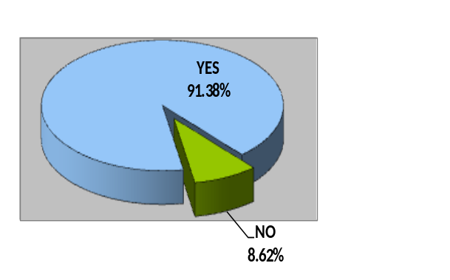

The pie diagram shows that 91.38% of the mothers had knowledge about the importance of antenatal care and the remaining 8.62% did not.
Figure-06: Knowledge of respondents about the timing of receiving antenatal care
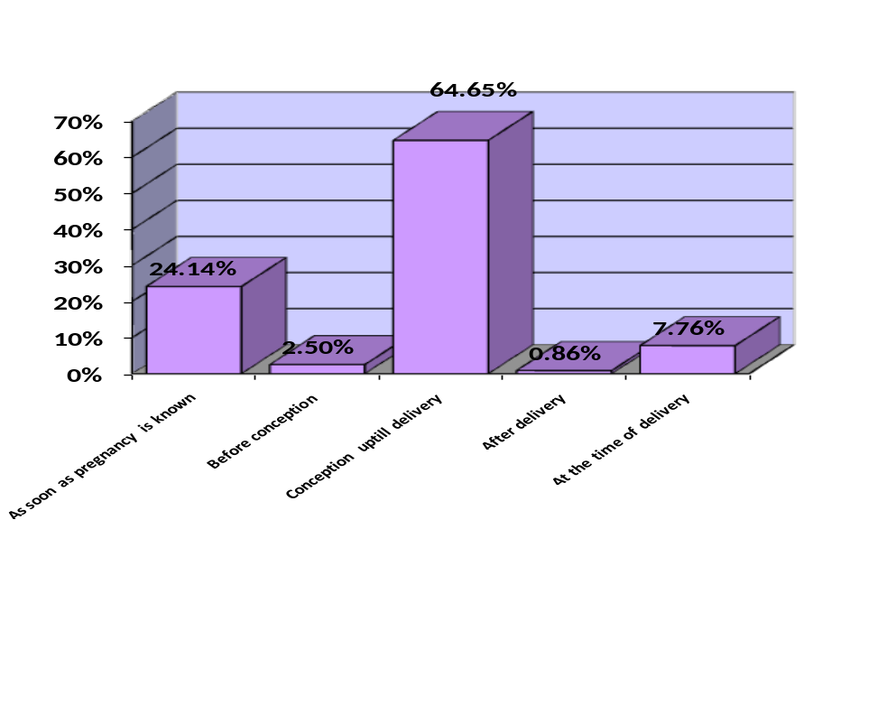From the above bar diagram it is revealed that 64.65% of mothers had the knowledge of receiving antenatal care during pregnancy, 24.14% at the time of pregnancy, 7.76%at the time of delivery, 2.50% before pregnancy and 0.86% after delivery.

Table No-9: Knowledge of mothers about recommended antenatal visits

Number of visits | Total No | Percentage (%)
One | 14 | 12.06
Two | 23 | 19.82
Three | 15 | 12.93
Four | 64 | 55.17
Total | 116 | 100

Table shows that 55.17% of the mothers know about the antenatal visit as four visits while 12.06% know it as once.
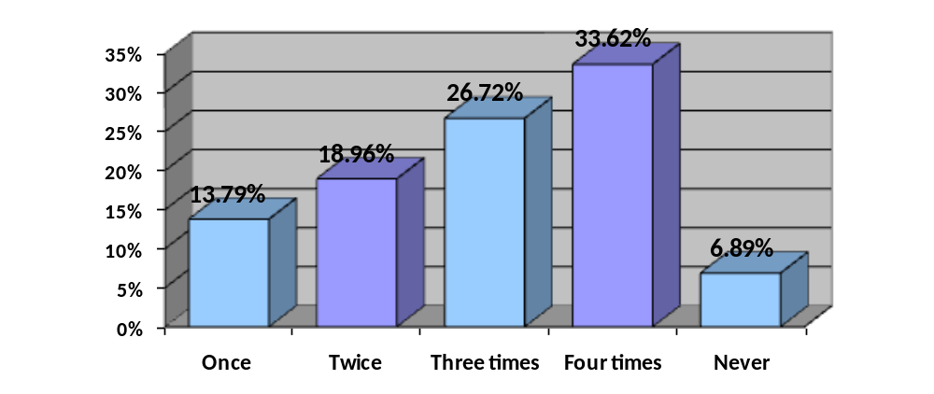Figure-07: Number of Antenatal visits received by the respondents during the
last pregnancy

The bar diagram shows that during their last pregnancy, 33.62% of mothers went for antenatal check-up four times, 26.72% went three times, 18.96% went twice and 13.79% went once. The remaining 6.89% of mothers did not go for antenatal check-up during their last pregnancy.
Table No-10: Knowledge about the place where antenatal care is given.

Center of visit | Total No | Percentage (%)
Upozilla health complex | 53 | 44.68
Union sub-center | 9 | 7.75
Community clinic | 8 | 6.89
Private | 31 | 26.72
At home by trained dai | 15 | 12.93
Total | 116 | 100

Table shows that 44.68% know about the antenatal care given from upozilla health
complex, 6.89% from community clinic.
Table No-11: Place where respondents received antenatal care

Place | Total number | Percentage (%)
Upozilla health complex | 41 | 35.34
Union sub-center | 06 | 5.17
Community clinic | 10 | 8.62
Private | 37 | 31.90
At home by trained dai | 19 | 16.38
Others | 03 | 2.59
Total | 116 | 100

Table shows that 35.34% received antenatal care from upozilla health complex, 31.90% received from private clinic, 16.38% from home

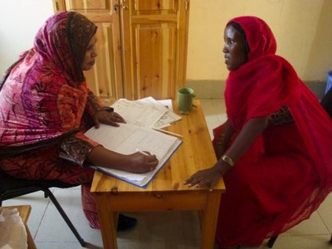

Table No-12: Distribution of respondents according to care provider

Given by | Total Number | Percentage (%)
Doctor | 79 | 64.14
Paramedics | 7 | 6.03
Trained Dai | 24 | 20.70
Others | 6 | 5.17
Total | 116 | 100

Table show that 64.14% deliveries were conducted by doctors, 20.73% was conducted by trained dai, and rest 5.17% from others.

Table No- 13: Distribution of respondents according to status of TT vaccination

Status | Total Number | Percentage (%)
Taken | 112 | 96.55
Not taken | 4 | 3.45
Total | 116 | 100

Table shows that 96.55% mothers taken TT vaccine and 3.45% did not take.
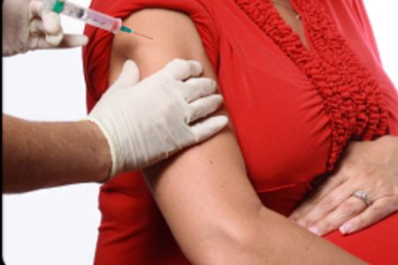

Table No-14: Distribution of respondents according to time of receiving TT vaccine
Number of TT vaccine | Total Number | Percentage (%)
5 TT vaccine from 15 years | 27 | 23.28
<5 TT vaccine from 15 years | 14 | 12.06
2 TT vaccine during each pregnancy | 67 | 57.76
<2 TT vaccine during each pregnancy | 08 | 6.90
Total | 116 | 100

Table shows that 57.76% mother taken two TT vaccine during pregnancy, 23.28% taken five TT vaccines from 15 years.

Table No-15: Knowledge about the warning sign of pregnancy *(n=369)
Warning Signs | Total Number | Percentage (%)
Vaginal bleeding | 75 | 20.32
Leg edema | 74 | 20.05
Convulsions | 79 | 21.40
Vaginal discharge | 50 | 13.55
Headache | 62 | 16.80
Severe fever (>3 days) | 29 | 7.85
Total | 369
*Multiple responses
Table shows that 20.32% mother know about the vaginal bleeding, 20.05% know about leg edema, 21.40% know about the vaginal disturbance, 16.80% know about headache, and 7.85% know about severe fever.

Table No-16: Distribution of respondents by antenatal complications *(n=160)

Complications | Total No | Percentage (%)
Anaemia | 27 | 16.87
Hypertension | 29 | 18.12
Threatened abortion | 4 | 2.5
Severe vomiting | 62 | 38.75
No complications | 15 | 9.37
Others | 23 | 14.37
*Multiple responses

Table shows that 38.75% suffered from severe vomiting, 18.12% from hypertension and 16.87% from anemia.

Table No-17: Distribution of respondents by place of delivery *(n=257)

Place | Total No | Percentage
Home | 162 | 63.03
Clinic | 24 | 9.33
Medical college | 46 | 17.89
Upozilla health complex | 25 | 9.72
*Multiple responses
Table shows that 63.03% respondents delivered at home, 9.33% delivered at clinic, 17.89% delivered in medical college and 9.72% in Upozilla health complex.

Figure-08: Distribution of respondents by mode of delivery *(n=257)

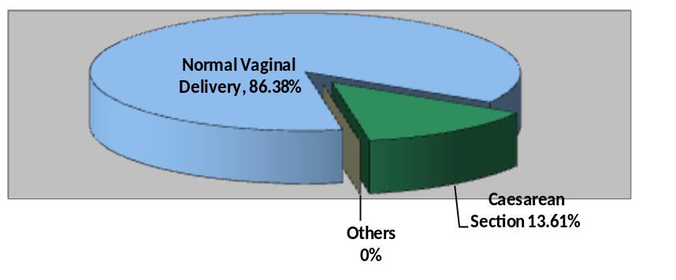

*Multiple responses
The above pie diagram shows that 86.38% of mothers delivered their child by normal vaginal delivery and 13.61% by caesarean section.

DISCUSSION

Antenatal care is an important issue which is given priority in the states recent health policy as well as individual level. This cross sectional descriptive study was carried out to find out the knowledge and practice regarding antenatal care of rural mothers. Hundred and sixteen mothers having at least on child of two years were interviewed.

Socio-demographic information of the respondent
In this study regarding the age, the highest number of the respondents belong to the age group of 22-25 years (31.03%), 25.8% in the range of 30-35 years and 19.82% in the range of 26-29 years, another 15.51% to the age group of 18-21 years. Only 7.75% mothers are over 35 years of age having child less than 2 years. It is a positive side that in our study no mother found below the age of 18 years. (Ref: Tab.1)
Regarding the occupation, 93.10% respondents are housewives. Among them, highest number of respondents i.e. 54.31% studied up to secondary level which is much higher than national literacy rate (Bangladesh literacy rate is 26.29%, according to Bangladesh Literacy Survey 2010). 29.31% respondents studied up to primary level which is almost near to the national literacy rate 28.30%. Our survey shows that 7.75% studied up to higher secondary or above where national literacy rate is 3.81% and less but not negligible 9.40% are illiterate. So, in contrast to Bangladesh Literacy Survey, rural mother’s educational status in these two villages is satisfactory. (Ref: Fig. 1&2).
Regarding occupation of the respondent’s husbands 31.03% are day labourer, 29.31% are businessmen, 17.24% are working abroad, 17.24% are service holder and 5.17% are engaged in other occupations. Regarding the monthly income of the respondent’s husbands, 23.28% earn 3000-6000taka, 22.42% earn below 3000taka, 19.83% earn 12000-15000taka and 18.11% earn 9000-12000taka. It reveals that 22.42% of respondent’s husbands earn less then 36,000 taka per year which is far less then national (53,236 taka, according to Bangladesh Bureau Survey per capita GDP 2011 )

and another 23.28% earn 36,000-72,000 taka indicates a few more fall below the level of poverty. (Ref: Tab.2 & Fig.3)
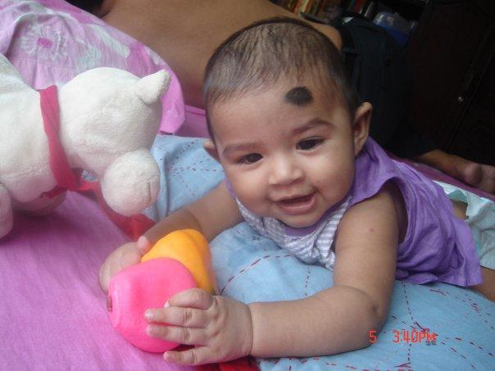
Majority number (67) 57.75% respondents have 1-2 children and 42.24% (49mothers) have children 3 or more. It shows that family planning practice is not satisfactory in these two villages. Among them, 43.10% having their last child of 19-24 months of age, 21.55% of 13-18 months, 18.96% of 7-12months and 16.37% of 0-6 months of age. (Ref: Tab no: 3&4)

Regarding menarche the highest number (77.58%) of the age group belongs to 13-15years of age. Most of respondents (61.20%) got married at the age of 18-22years. 34.48% at the age below 18years, which is not satisfactory regarding legislation of age at marriage (for female age at marriage 18 years) of Bangladesh Government. During delivery of 1st child, majority of the respondents (62.93%) are in the age group of 18-21 years. Another study showed that south Asian countries have high proportion of teenage pregnancies, since early marriage is common and there is a social expectation to have a child soon after marriage. (Ref: Tab. 5, 6&7).

Knowledge of the respondents about the importance of ANC

It is seen that 91.38% mothers know about the importance of ante natal care, while 8.62% have no idea about this. Among them 64.65% know that ANC should be taken from conception to before delivery. 55.17% respondents know that at least four visits should be taken during ante natal period whether 19.82% know that the visit number is 2.Study in Bangladesh showed that teenage mothers are less likely to receive timely prenatal care & they have higher rate of certain risk factors for poor pregnancy outcome. It is observed that, 45.68% mother know that ANC should be taken from Upozilla Health Complex and 26.72% know from private clinic. Most remarkable finding is, 12.93% know that the care should be taken by trained dais. 21.40% of the mothers among the study group have knowledge about the common warning signs of pregnancy, that is convulsion and 20.05% know about leg edema and rest of the mothers know about other warning sign that is vaginal bleeding (20.32%), visual disturbance (13.55%), headache (16.80%) and fever (7.85%) (Ref: Tab.8, 9, 14 and fig.4 & 5).

Practice of respondents regarding ante natal care

Regarding ante natal care practice, 33.62% mothers went for antenatal care checkup four times, 26.72% for three times, 18.96% went twice and only once 13.79%. Remarkable finding is that 6.89% didn’t go for antenatal care during their last pregnancy. 35.34% took ante natal care from Upozilla Health Complex and 31.90% from private clinic while 16.38% by trained dais at home. Rest of them took from other health centers like community clinic, union sub-center etc. Among them highest number of mothers that is 68.14% took health care service by doctor and 20.70% by trained dais and rest of the mothers from paramedics and other respective (Ref: Fig.6 & Tab.10 & 11).

A good percentage of mothers that is 112 (96.55%) took TT vaccine. Majority of them 57.76% took during their each pregnancy while 23.28% took after 15 years of age. It is not negligible that 12.06% do not complete their TT vaccine after the age of 15years and 6.90% pregnant women do not complete their TT vaccine during their pregnancy. (Ref: tab.12 & 13).
Majority 63.03% of respondent’s delivery occurred at home & only 17.89% at hospital, 09.72% in UHC & 9.33% in clinic. Among the mode of delivery normal vaginal delivery 86.38% & the caesarean section 13.61%. (Ref: Tab.16 & Fig.7)
CONCLUSION

Proper ante-natal care & practice is of immense importance for a healthy nation ahead. Developing countries like ours need to find out the ways for ante-natal care & practice within the capacity of the families – a cost effective one. This study was a pilot attempt to see the status of ante natal knowledge & practice & to find out the aspects need to be improved upon. It can be inferred from this study that, there is lack of knowledge regarding the number of ante-natal visits, warning signs of pregnancy amongst rural mothers. Majority of the respondents are not informed about TT vaccination & hence the practice is far more worst. Besides, seeking service from health care professionals during delivery was found poor.

RECOMMENDATION

Following recommendations are made based on study findings:
- Both knowledge & practice regarding ante-natal care should be ensured by health education.
- Minimum 4 ante-natal visit for all pregnant women should be ensured. Because regular ante natal check up is essential for screening of high risk cases.
- All scheduled doses of TT vaccine should be ensured.
- Increase awareness about danger signs of pregnancy by different media with emphasis on mass media.
5. Marriage below 18 years should be discouraged.

